MINI TAC TOE
Mini Tac Toe was a joint effort out of the ETC West office. I developed the idea with Dave Young our Architectural Regional Manager and the support of Thomas Schneider who heads up our demo loan program. We wanted to create a fun way to show off the Eos family of consoles and our Source Four Minis.
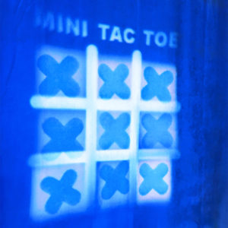
What started as a very simple idea quickly turned into a much more in-depth project. We continued to develop ideas about how the console’s Magic Sheet should function for playing the game. The Magic Sheet is much more than just a touch screen interface, it has a complex set of macros running in the background that analyze the game board after each turn. To do this, we broke down the game of Tic Tac Toe into a mathematical equation of how someone would win or lose. From this we assigned numerous dummy channels in the console to help monitor the game board. And through the use of Query in the console we were able to analyze these dummy channels in order to decide if someone won or if there was a draw. Doing this on a console is a lot harder than you might expect as we are not using a computer programming language like C++ or Java, and just using the options native in the console.

We wanted to show the possibilities of what Magic Sheets can do if you put your mind and programming skills to it. I think it has turned out really well and it’s been a hit so far! We are still developing this further as a side project, and the next option is to have a single player mode where you can AutoPlay the console. It’s worthy to note that you can just open the showfile and play the game virtually on the console or nomad software. It’s a great way to spend a 10 minute break from tech or set it up on a multi-console system and the LD and Programmer can play each other while not even being in the same room.
Gear:
18 Source 4 Minis (Various Mini Models, 3000K, 4000K, 5000K, Incandescent): 9 with 36 Degree Lens, 9 with 50 Degree Lens.
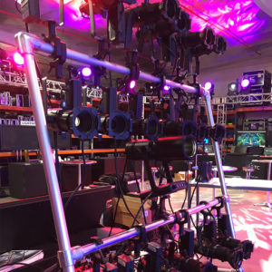
1 Irideon FPZ Portable (Projected the Tic Tac Toe Board).
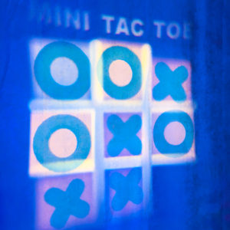
19 Custom Sized Transparency Gobos, 9 X’s, 9 O’s, 1 Tic Tac Toe Board.
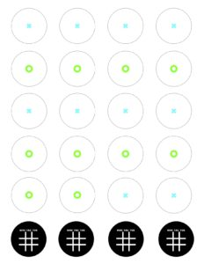
Power:
1 20 Amp Circuit is all it took to run the console and the 19 lights. Pretty Impressive!
Console: Eos Titanium.
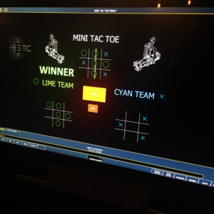
Showfile:
(Software Version 2.5 or higher). It can run on any of our consoles. Nomad Software, Element, Ion, Gio, Gio@5, Ti.

