Sky Beam 14RX
(Super Beam)
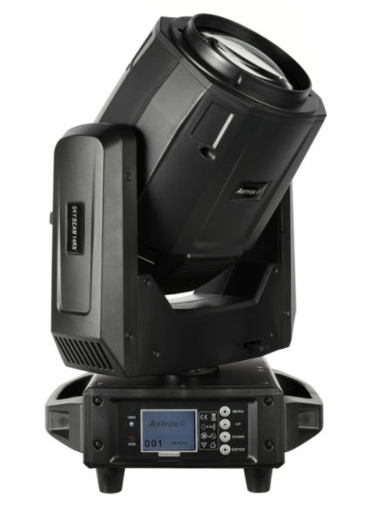
USER MANUAL

CONTENTS
Chapter 1 Installation and attention 3
1.1 Maintenance 3
1.2 Statement 3
1.3 Safety Precaution 3
1.4 Product Instruction 3
1.5 Cable connection（DMX） 4
1.6 Rigging (Optional) 4
Chapter 2 Panel operation 6
2.1 Brief 6
2.2 Operation 6
2.2.1 Operate light with touch or KEY 6
2.2.2 Parameter value setting 6
2.2.3 Boolean parameter setting 7
2.2.4 Sub Menu（Parameter） 7
2.3 Operation and parameter instruction 7
2.3.1 ADDR--> Address: Set DMX Address 8
2.3.2 MODE--> WorkMode: Set Light work mode 8
2.3.3 DISP-->DISPLAY: Set display 9
2.3.4 TEST--> TestMode 9
2.3.5 ADVA-->Advanced: Set light run parameter 10
2.3.6 STAT-->Status: View status 11
Chapter 3 Channel description 12
3.1 Channel table 12

Chapter 1 Installation and attention

1.1 Maintenance
- To reduce the risk of electrical shock or fire, do not expose this unit to rain or moisture.
- Intermittently using will extend this item’s service life.
- Please clear the fan, fan net , and optical lens in order to keep good work state.
- Do not use the alcohol or any other organic solvent to wipe the shell.

1.2 Statement
The product has perfect performance and integrity packing. All users should be strictly complying with the warning and operating instructions as stated. Or we aren’t in charge of any result by misuse. Any damage resulting by misuse is not within the Company’s warranty. Any fault or problem caused by neglecting the manual is also not in the charge of dealers.
Note: All information is subject to change without prior notice.

1.3 Safety Precaution
- In order to guarantee the product’s life, please don’t put it in the damp places or even the environment over 60 degree.
- Always mount this unit in safe and stable matter.
- Install or dismantle should be operated by professional engineer.
- Using lamp，the change rate of power voltage should be within±10%. If the voltage is too high, it will shorten the light’s life; if it’s not enough, will influence the effect.
- Please restart it 20 minutes later after turning off the light, until full-cooling. Frequent switching will reduce the life span of lamps and bulbs; intermittent using will improve the life of bulbs and lights.
- In order to make sure the product is used correctly, please read the Manual carefully.

- 1.4 Product Instruction

ARTFOX Sky Beam 14RX is the next generation beam moving head powered by the brilliant 295w 14R MSD Discharge Lamp (1,500 hr.),It features the biggest optical lens to achieve Powerful wide range and sharp beam , Includes: 6 Prism FX, 15 prism effects ,Rainbow wheel, Frost Filter, Motorized Focus, 14 dichroic colors + white, 8 static GOBOs + open and 5 colorful glass gobos.
Sky beam 14RX features awesome 3D dynamic Prism effects, It features 2 Prism Wheels, total 6 Rotating prisms, 2 Dynamic 3D Prism, 15 kinds of Combined Prisms effects;
Features:
R14 295w lamp
Two Prisms wheel ( total 6 prisms, 15 prisms effects. )
6 colors Rainbow Effects
Beam Angle: 1.8°
Frost
13 fixed gobos (8 fixed gobos + 5 glass gobos) + Open
13 colors + Open
Touch color screen
PowerCon in/out
Light Source:
• 295W R14 LL MSD Discharge Lamp (1,500 hr.)
• Color temperature: 8000K
Color Wheel:
• 13 dichroic colors + white (Includes CTO, CTB & UV)
• Indexable color wheel for split colors
GOBO Wheel:
• 8 static GOBOs + 5 Glass colorful gobo +open
• GOBO Shake Effect
2 Prism Wheel:
• 6 Rotating prisms, Dynamic 3D Prism, 15 kinds of Combined Prisms effects;
. Wheel 1： 16-facet Circular +6 -facet Linear + 6&12 facet Dynamic 3D Prism
Wheel 2: 32- facet Circular + 6-facet Linear+ (8+16+24) facet Dynamic 3D Prism.
Control:
• 2 DMX Channel Modes: 14/18 Channels
• Touch Screen with 4-button function menu
• Control Mode: DMX512, Auto-Run, Sound Active
• 0-100% smooth dimming
• Various strobe speeds
Pan/Tilt:
• Pan: 540 degrees (plus 16-bit fine pan)
• Tilt: 270 degrees (plus 16-bit fine tilt)
Connections:
• DMX Connections: 3-pin or 5-pin DMX In/Out (Data link max: 32 fixtures)
• Power Connections: Powercon In & Out
Electrical:
• Multi-voltage operation: 100-240V, 50/60Hz
• Max power consumption: 360W (@120V),
Dimensions & Weight:
• Dimension: 13.8” (L) x 13.5” (W) x 22.25” (H) / 350 x 343.5 x 565mm
• Weight: 34.1lbs. / 15.5kg.
What’s Included:
• Folding Clamps
• Power cable & Date Cables

1.5 Cable connection（DMX）
Use a cable conforming to specifications EIA RS-485: 2-pole twisted, shielded, 120Ohm characteristic impedance, 22-24 AWG, low capacity. Do not use microphone cable or other cable with characteristics differing from those specified. The end connections must be made using XLR type 3 or 5-pin male/female connectors. A terminating plug must be inserted into the last projector with a resistance of 120Ohm (minimum 1/4 W) between terminals 2 and 3.
IMPORTANT: The wires must not make contact with each other or with the metal casing of the connectors. The casing itself must be connected to the shield braid and to pin 1 of the connectors.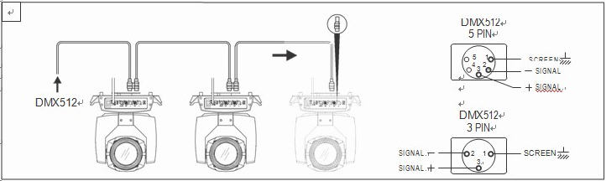
Figure 1 DMX Cable connection

1.6 Rigging (Optional)
This equipment can be positioned and fixed by clamp in every direction of the stage. Locking system makes it easy to fasten to the bracket.
Attention! Two clamps are needed to fix the equipment. Every clamp is locked by fastener of 1/4 kind. Fastener can only be locked clockwise.
Attention! Fasten a safety string to the additional hole of side aluminum piece. The secondary accessory could not hang on the delivery handle. Nip the equipment on bracket.
- Check if rigging clamp (not including the one inside) damaged or not? If stand ten times weight as the equipment. Make sure the architecture can stand ten times weight as all the equipment, clamps, wirings and other additional fixtures.
- Screws for clamping must be fixed firmly. Take one M12 screw (Grade 8.8 or higher) to clamp bracket, and then screw the nuts.
- Level the two hanging points at the bottom of clamp. Insert fastener to the bottom, lock the two levers by 1/4 rotating clockwise; then install another clamp.
- Install on safety string which stands at least ten times weight as equipment. Terminal of the accessory is designed for clamps.
- Make sure pan/tilt lock unlocked or not. Keep the distance more than 1M from equipment to flammable material or lighting source.
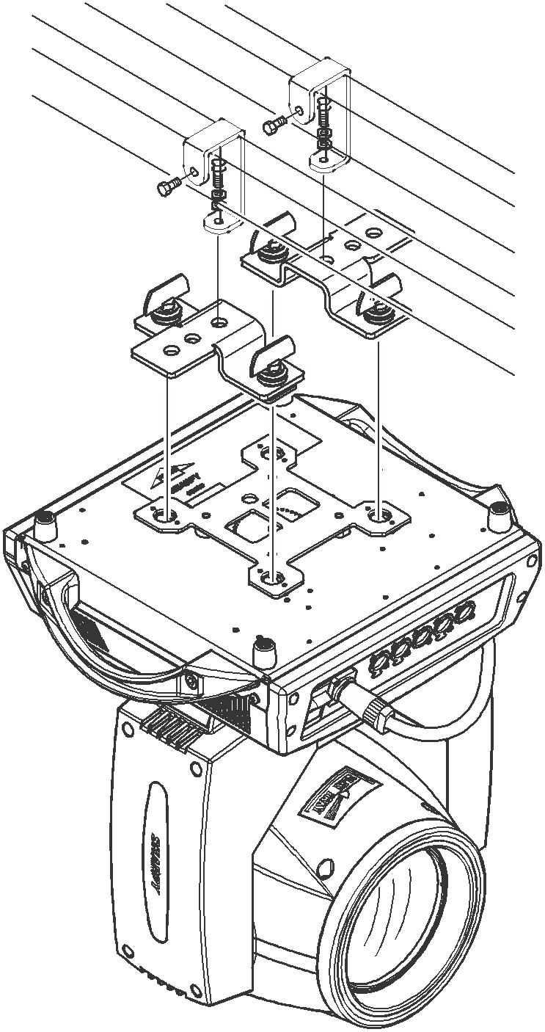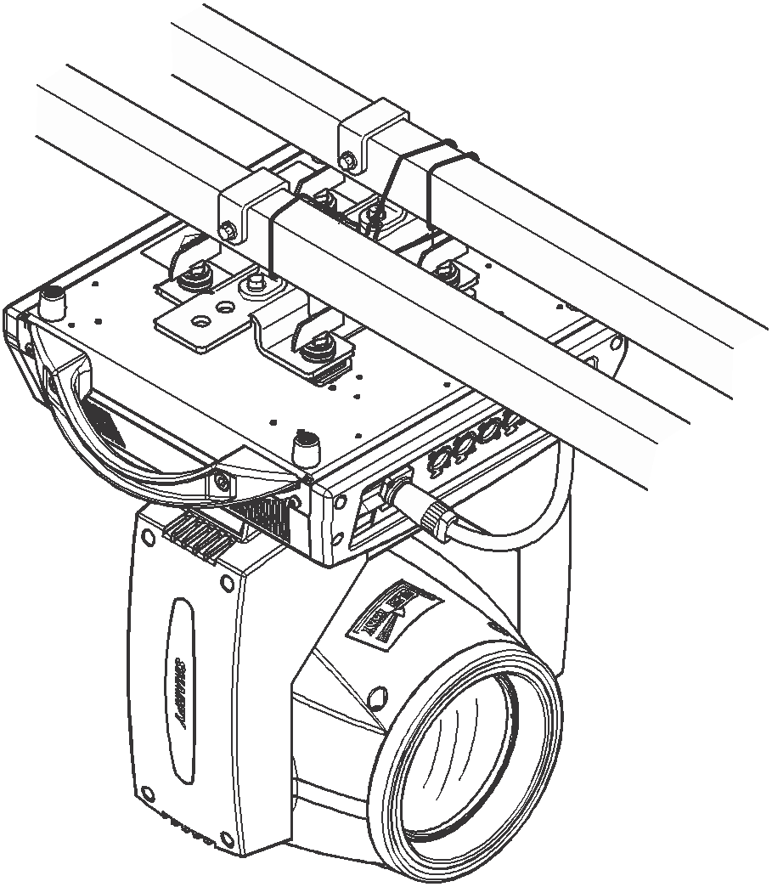
Figure 2 Installation

Chapter 2 Panel operation

2.1 Brief
The light panel diagram show as Figure 3, Left area is TFT Displayer, support touch, and right area is KEY, both of touch and KEY can operate light and setting.
Display & operation just like “Android operation system”, touch the item will set or modify setting.
Note: Prevent damage the touch or TFT displayer, do not use sharp objects chick displayer.
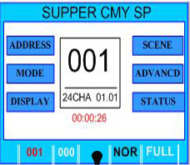
Figure 3 Panel diagram

2.2 Operation

2.2.1 Operate light with touch or KEY
- The left area is TFT Displayer and touch, chick item or value with finger will to complete operation of set light setting (parameters) or view light state.
- The area on the right hand side is 4 KEY. As auxiliary input interface, if disable touch function,, the KEY can been choose to set the parameter.

2.2.2 Parameter value setting
When the selected item is value need to been modified, the dialog shown in Figure 4 will popup.
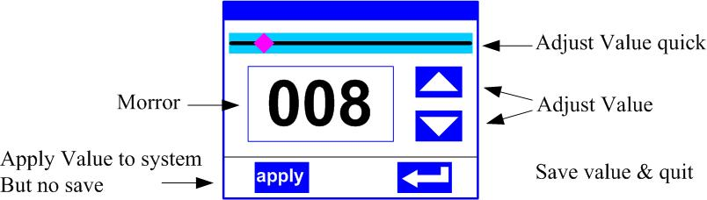
Figure 4 Dialog of value setting
- Modify value：Can quickly modify value via pull the slider to the desired position, or click the button of ‘up’ or ‘down’ whit finger on the right side to set the exact desired value, another way is roll encoder on the right hand side of panel.
- Apply value：When Value had been modified, Then press the bottom of ‘apply’ in the left corner to apply to the light, but haven’t saved；
- Save Value：Any time, click on the lower right corner of the "OK" button, the setting will be saved into internal memory.

2.2.3 Boolean parameter setting
- When the selected parameters is a Boolean value (such as ON or OFF), can directly modify setting by chick corresponding item, the setting will been saved right now.
- When the parameter is a key item, chick corresponding item, a dialog shown in Figure 5 will been popup ask for the confirm. Chick ‘sure’ to confirm.
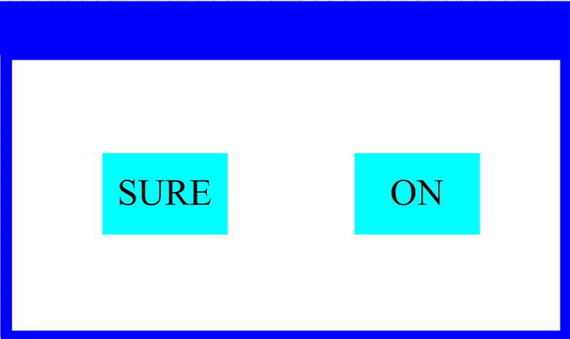
Figure 5 Dialog of confirm

2.2.4 Sub Menu（Parameter）
Chick item of main menu, enter corresponding sub menu, shown in Figure 6, total 6 sub menu, includes class of parameter and status:
- ADDRESS：Set light DMX address.
- WORKMOD：Set light work mode, master or slave mode when in auto run mode.
- DISPLAY： Set display parameter, e.g. selecting language.
- TEST：Used for test light, modify DMX channel data to test function， the corresponding function of reference channel function table.
- ADVANCE：Set light running parameter.
- STATUS：View light current status.
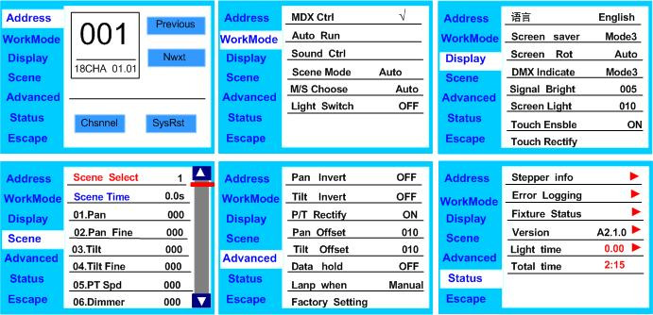
Figure 6 Parameter menu

2.3 Operation and parameter instruction
Via following operation, enter sub menu (parameter menu) shown in Figure 6
- In main menu, chick 1/6 function button into corresponding parameter menu.
- In sub menu (page), chick main item on the left side of displayer, can shift to corresponding sub menu(page) quickly.

2.3.1 ADDR--> Address: Set DMX Address
Click and select the "ADDR", can enter the page of DMX address setting, range from 1 to 512, the address code shouldn’t is not greater than (512- channels quantity), otherwise the light will not been controlled. Following is the operation:
Enter the page of DMX address, as shown in Figure 7, click the blank area in right side of display will pop-up dialog as in Fig.4, modify value, then click ‘ENTER’ to confirm and save DMX address code.
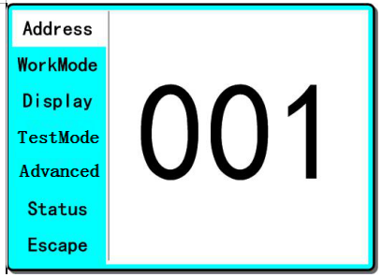
Figure 7 page of DMX Address

2.3.2 MODE--> WorkMode: Set Light work mode
Enter the page of ‘WorkMode’ as shown in Figure 8 and modify setting. Can set light work mode, control lamp and DMX channel mode.
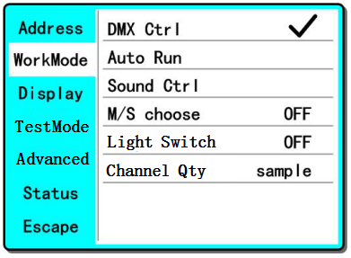
Figure 8 page of work mode
◆ DMX Ctrl: Choose to set DMX Mode,
◆ Auto Run: Choose to set Auto Mode,
◆ Sound Ctrl: Choose to set Sound Mode,
◆ M/S Choose:Available just in ‘AUTO RUN’ or ‘SOUND Ctrl’ mode.
ON--> Master. (Data will be sent to other slave lamp immediately.)
OFF--> Slaver. (NOT send data to other lamp via DMX Cable).(Default)
◆ Light Switch:
ON--> Turn on the light,
OFF--> Turn off the light.
◆ Channel Qty: Light support 2 DMX Channel mode: sample or extend。
Simple --> 18CH.(Default)
Expand--> 20CH(or null).

2.3.3 DISP-->DISPLAY: Set display
Light support 2 language, rotation display. Enter page as shown in Figure9 to set parameter following:
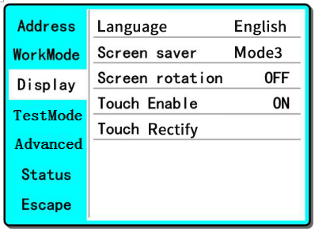
Figure9 page of display
◆ Language: English / Chinese.
◆ Screen Saver: When panel is idle(these is no operation in 10 second), display will enter saver status.
OFF--> No screen saver.
Mode1--> Power-saving mode, turn off the display.
Mode2--> Displays the current address.
Mode3--> Displays the icon and the current working mode.(Default)
◆ Screen Rotion: To turning display.
ON--> Normal display.(Default)
OFF--> 180° turning display.
◆ Touch enable：Disable or enable touch function,.
ON--> Enable touch function.(Default)
OFF--> Dosable touch function.
◆ Touch adjust：Adjust touch function. Normally, not enter this item.

2.3.4 TEST--> TestMode
Enter the page as shown in Figure 10, Light will into test mode, in this mode, the light does not receive the data for DMX controller.:
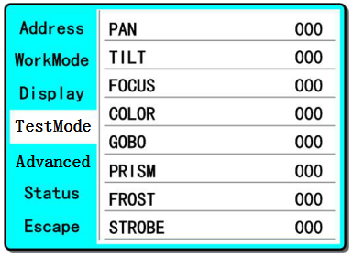
Figure 10 page of Test
◆ PAN: range for 0 to 255;
◆ TILT: range for 0 to 255;
◆ FOCUS: range for 0 to 255;
◆ COLOR: range for 0 to 255;
◆ GOBO: range for 0 to 255;
◆ PRISM: range for 0 to 255;
◆ FROST: range for 0 to 255;；
◆ STROBE: range for 0 to 255;

2.3.5 ADVA-->Advanced: Set light run parameter
Enter the page as shown in Figure 10, set the parameter of light:
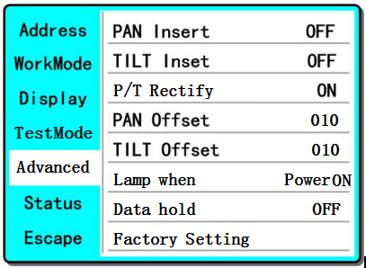
Figure 11 page of run parameter
◆ Pan Invert: Reverse PAN move
OFF--> Pan Normal move.(Default)
ON--> Reverse PAN move.
◆ Tilt Invert: Reverse TILT move
OFF--> Tilt Normal move.(Default)
ON--> Reverse Tilt move.
◆ P/T Rectify: Disable or enable position rectify function.
OFF--> Disable P/T rectify
ON--> Enable P/T rectify-(Default)
◆ Pan Offset: Set PAN original position. Default: 10
◆ Tilt Offset: Set TILT original position. Default: 10
◆ Lamp when:
PowerON--> Turn on the lamp when power on.(Default)
RstDone--> Turn on the lamp after reset.
Manual--> Manually turn on the lamp.
◆ Data hold:
OFF--> When no DMX signal, return to middle position.(Default)
ON--> When no DMX signal, stop in the final position.
◆ Factory Setting: Restore all parameter to factory setting.

2.3.6 STAT-->Status: View status
Enter the page as shown in Figure 12:
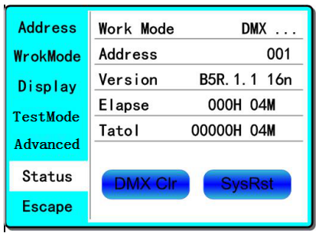
Figure 12 page of status
◆ Work Mode: Show the current working mode.
◆ Address: Show the current address.
◆ Version: Show the version of the light.
◆ Elapse: Working hours after turning on.
◆ Tatol: Cumulative hours of operation
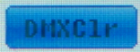
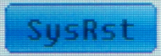
When <Data hold> set <ON>,click to clear DMX data, and make the lamp return to the middle position.
Click to reset.

Chapter 3 Channel description

3.1 Channel table
Table 1 Channel brief

CH1 | PAN | 0-255 | 0-540°
CH2 | PAN 16bit | 0-255
CH3 | TILT | 0-255 | 0-270°
CH4 | TILT 16bit | 0-255
CH5 | XY Speed | 0-255 | Fast to slow
CH6 | Dimmer | 0-255 | 0-100%
CH7 | Strobe | 0-3 | Dark
CH7 | Strobe | 4-103 | Slow strobe to fast strobe
CH7 | Strobe | 104-107 | White
CH7 | Strobe | 108-207 | Slow strobe to fast strobe(mode 2)
CH7 | Strobe | 208-212 | White
CH7 | Strobe | 213-251 | Free strobe
CH7 | Strobe | 252-255 | White
CH8 | Frost | 0-127
CH8 | Frost | 128-255 | Insert frost
CH9 | Color | 0-4 | White
CH9 | Color | 5-9 | White + COLOR1
CH9 | Color | 10-14 | COLOR1
CH9 | Color | 15-19 | COLOR1 + COLOR2
CH9 | Color | 20-24 | COLOR2
CH9 | Color | 25-29 | COLOR2 + COLOR3
CH9 | Color | 30-34 | COLOR3
CH9 | Color | 35-39 | COLOR3 + COLOR4
CH9 | Color | 40-44 | COLOR4
CH9 | Color | 45-49 | COLOR4 + COLOR5
CH9 | Color | 50-54 | COLOR5
CH9 | Color | 55-59 | COLOR5 + COLOR6
CH9 | Color | 60-64 | COLOR6
CH9 | Color | 65-69 | COLOR6 + COLOR7
CH9 | Color | 70-74 | COLOR7
CH9 | Color | 75-79 | COLOR7 + COLOR8
CH9 | Color | 80-84 | COLOR8
CH9 | Color | 85-89 | COLOR8 + COLOR9
CH9 | Color | 90-94 | COLOR9
CH9 | Color | 95-99 | COLOR9 + COLOR10
CH9 | Color | 100-104 | COLOR10
CH9 | Color | 105-109 | COLOR10 + COLOR11
CH9 | Color | 110-114 | COLOR11
CH9 | Color | 115-119 | COLOR11 + COLOR12
CH9 | Color | 120-124 | COLOR12
CH9 | Color | 125-129 | COLOR12 + COLOR13
CH9 | Color | 130-134 | COLOR13
CH9 | Color | 135-139 | COLOR13 + WHITE
CH9 | Color | 140-144 | COLOR14
CH9 | Color | 145-149 | COLOR14 + WHITE
CH9 | Color | 150-200 | Rotate forward (fast to slow)
CH9 | Color | 201-255 | Rotate reverse (slow to fast)
CH10 | Gobo | 0-4 | White
CH10 | Gobo | 5-9 | GOBO1
CH10 | Gobo | 10-14 | GOBO2
CH10 | Gobo | 15-19 | GOBO3
CH10 | Gobo | 20-24 | GOBO4
CH10 | Gobo | 25-29 | GOBO5
CH10 | Gobo | 30-34 | GOBO6
CH10 | Gobo | 35-39 | GOBO7
CH10 | Gobo | 40-44 | GOBO8
CH10 | Gobo | 45-49 | GOBO9
CH10 | Gobo | 50-54 | GOBO10
CH10 | Gobo | 55-59 | GOBO11
CH10 | Gobo | 60-64 | GOBO12
CH10 | Gobo | 65-69 | GOBO13
CH10 | Gobo | 70-128 | Rotate forward (fast to slow)
CH10 | Gobo | 129-131 | Stop
CH10 | Gobo | 132-190 | Rotate reverse (slow to fast)
CH10 | Gobo | 191-195 | Shake slow to fast GOBO1
CH10 | Gobo | 196-200 | Shake slow to fast GOBO2
CH10 | Gobo | 201-205 | Shake slow to fast GOBO3
CH10 | Gobo | 206-210 | Shake slow to fast GOBO4
CH10 | Gobo | 211-215 | Shake slow to fast GOBO5
CH10 | Gobo | 216-220 | Shake slow to fast GOBO6
CH10 | Gobo | 221-225 | Shake slow to fast GOBO7
CH10 | Gobo | 226-230 | Shake slow to fast GOBO8
CH10 | Gobo | 231-235 | Shake slow to fast GOBO9
CH10 | Gobo | 236-240 | Shake slow to fast GOBO10
CH10 | Gobo | 241-245 | Shake slow to fast GOBO11
CH10 | Gobo | 246-250 | Shake slow to fast GOBO12
CH10 | Gobo | 251-255 | Shake slow to fast GOBO13
CH11 | 7 Colorful | 0-127 | None
CH11 | 7 Colorful | 128-255 | Insert 7 colorful
CH12 | Prism1 | 0-127 | None
CH12 | Prism1 | 128-255 | Prism1
CH13 | Prism1 Rot | 0-127 | 0-400 degrees
CH13 | Prism1 Rot | 128-187 | Rotate forward (fast to slow)
CH13 | Prism1 Rot | 188-195 | Stop
CH13 | Prism1 Rot | 196-255 | Rotate reverse (slow to fast)
CH14 | Prism2 | 0-127 | None
CH14 | Prism2 | 128-255 | Prism2
CH15 | Prism2 Rot | 0-127 | 0-400 degrees
CH15 | Prism2 Rot | 128-187 | Rotate forward (fast to slow)
CH15 | Prism2 Rot | 188-195 | Stop
CH15 | Prism2 Rot | 196-255 | Rotate reverse (slow to fast)
CH16 | Focus | 0-255 | From far to near
CH17 | Lamp | 100-105 | Close lamp over 3 seconds
CH17 | Lamp | 200-205 | Open lamp over 3 seconds
CH18 | Reset | 210-215 | Reset over 3 seconds
CH18 | Reset | 220-235 | Close lamp over 3 seconds
CH18 | Reset | 240-255 | Open lamp over 3 seconds

